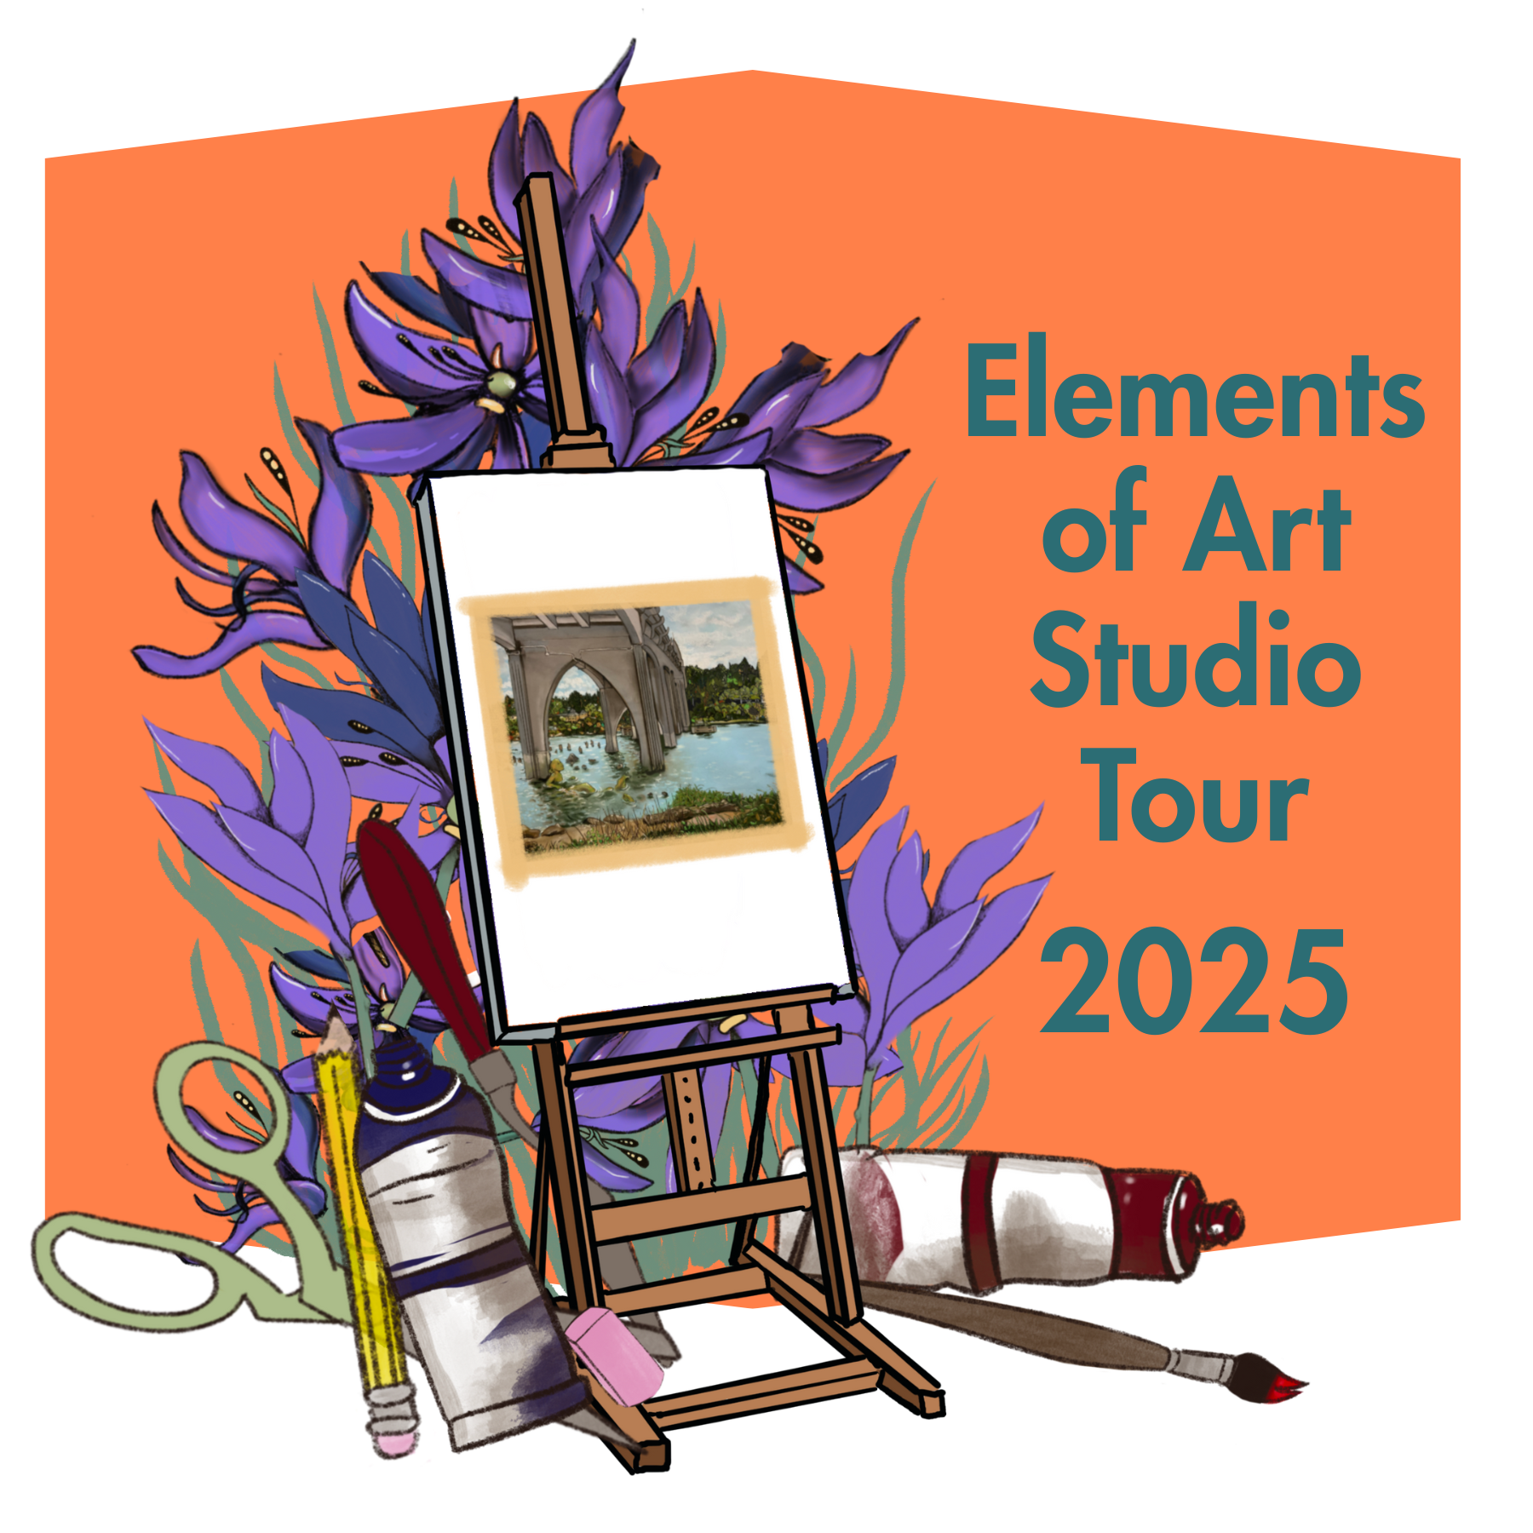

**Elements of Art**

**Artist Registration & Agreement**

**This is a hard copy of the questions asked on the**

**2025 Elements of Art Studio Tour.**

**Please complete and submit digitally at:** [**bit.ly/2025ElementsOfArtStudioTourArtistRegistration**](http://bit.ly/2025ElementsOfArtStudioTourArtistRegistration)

**Artist Basic Information**

* 1st Name
* Last Name
* Email
* Phone
* Phone Number that will Appear in Catalog/Tour Information (One that will reach you during the Tour)
* Studio Physical Address (Where Studio is) that will Appear in Catalog/Tour Information
  + Street Address
  + City
  + Zip
* Do you live in a Gated Community or in a residential community with a Homeowners Association (HOA)? Which one? If you do please check with them about specifics in participating in the Tour. They may have rules or guidelines dictating your participation, parking and having guests.
  + If you do, please check with them about specifics in participating in the Tour. They may have rules or guidelines dictating your participation, parking and having guests.
* Any specific directions for people such as Blue House with White Trim you’d like people to know about

Are you over the age of 18?

* Yes
* No
  + List Guardian Full Name
  + Relation
  + Email
  + Phone
* Guardian agrees to be with Artist during tour at all times

I will participate:

* Both weekends; September 6-7, Noon-4pm & September 20-21, 2025
* Noon-4pm
* September 2, Noon-4pm
* September 3, Noon-4pm
* September 16, Noon-4pm
* September 17, Noon-4pm
* Both weekends
* I’d like to only be listed in the Artist Directory

**We Need Your Help To Promote The Tour**

Click here if you are able to help:

* I can help distribute hard copies of items for the Tour such as Posters, Flyers, drop offs and pickups
* I can do some sharing of Tour and Artists on Various Social Media pages

**Social Media Info**

Please enter your artist website and social media info below. If you don’t have this, that is ok. We do not want your personal social media pages, just your artist ones. If you need help with an artist's social media/website, please attend our informational workshop.

We also think brick and mortar galleries/shops and other stores are important parts of the ArtsEcosphere, where else can your art be seen and/or purchased?

* Website
* Facebook
* Instagram
* Other Social, List Here
* Brick and mortar galleries/shops and other stores information including Name, Address, Website, Social Media

**Basic Artist Info**

These questions will help us with advertising the tour and you!

What types of Art do you do? Shortly describe your work and style (may be edited for length):

What Mediums do you work in? Check all that Apply:

* Ceramics
* Illustration
* Glass
* Painting
* Mixed media
* Fiber art
* Sculpture
* Quilting
* Printmaking
* Carving
* Jewelry
* Literary
* Beading
* Assemblage
* Graphic Arts
* Mosaics
* Collage
* Painting General
* Painting Acrylic
* Painting Oils
* Painting Watercolor
* Encaustic
* Graphite
* Color Pencil
* Drawing
* Wood Arts including Carving/Turning
* Pastel
* Gouache
* Pen & Ink
* Alcohol lnk
* Acrylic Pouring
* Paper Art
* Leatherworking
* Other

Artist Biography in 100 words or less (may be edited for length):

Artist’s Statement - Describe yourself and your artwork in 50 words or less (may be edited for length):

**Artist Images**

Submission of print-ready professional level photos is a basic requirement to be used in the various promotions of your studio and the Tour. Take as much care with your images as you do in creating your work. If you are unable to meet these standards on your own, seek professional help. Basic smartphone digital images should work for the most part in terms of quality. If this is a barrier for you, contact Elements of Art Tour Administration for guidance.

*Images that do not meet the following criteria will not be considered.*

* Backgrounds for three-dimensional work must be clean, simple, and plain, light or dark depending upon the tones and values of the object. Do not include your studio or household furniture in the background. “Artsy” backgrounds are discouraged. Present your work, not a background
* Two-dimensional work must be photographed from a centered position, perpendicular to the plane of the surface
* Do not photograph framed work, unless the frame is part of the work
* *All photos must be in focus*
* Exclude extraneous shadows on or near the work. Do not photograph objects against a wall where shadows of the object may appear (unless that work is a wall hanging)
* Avoid harsh lighting, burned out highlights and overly dense shadows
* Reflections of other objects on surfaces such as glass are not acceptable
* Reflections of light that obscure surfaces of the art are not acceptable
* Photographs must accurately represent the colors and values of the actual art.
* *The graphic designer is not responsible for images that do not accurately represent your work.*

Uploading of Images

Images must be titled with your name and the artwork/type of image name as shown below.

1 Name_title.jpg Sample: 1 JDSmith_SilverWater.jpg

Please upload the following types of Images, including up to 5 of art:

* 1 - Headshot or Image of you working (Please try not to submit a selfie, have someone take a photo of you)
* 2 - Image of Studio
* 3 - Detail Image of Studio
* 4 - Art Image
* 5 - Art Image
* 6 - Art Image
* 7 - Art Image
* 8 - Art Image

*Use of Images*

* *I understand that the Elements of Art Tour reserves the rights to reproduce the photos and information submitted for publicity purposes. If your art photos are not of publishing quality, those images will not be included in the tour. We will notify you if there are issues.*

**Studio Shopping & Information Experience**

All studios look different! This is the fun about visiting an artist's studio!

Some Artists work out of their mobile art studios, some work out of their kitchens, garages or other rooms in their house!

Tour participants will not have access to your entire home, rooms should be blocked (shut the door, block with tape with a note - a template will be provided to you) or be able to use your restroom. Tour participants have been told your restroom/s are not available for use. Please know where the closest public restroom is to direct them.

You can buddy up with another Artist, however it has been found that you will do better if they can see your studio, they want to see how YOU are producing work.

Do you need information on how to accept payments via Credit Card? Be sure to attend our informational session which will include some marketing and basic business information.

If you do take credit cards, cash, checks, which ones?

* Yes
  + If so, which ones?
    - AmEx ___ DISC ____ MC ___ VISA ____Cash ____Checks ____
* No
* Describe your studio space in 50 words or less (may be edited for length):
* Is your space accessible with a wheelchair or walker?

**Shared Studio?**

Some artists’ studio space may not be, what they deem, as presentable to the public. It is common for some artists to share exhibition space with other tour artists in their studios, so don’t let that hold you back. The quality of the artist’s work is the most important consideration.

NOTE: If you want to share a studio space with another artist, that artist MUST also fill out an application and pay the fees if they are going to be on the tour.

* Will you be sharing your space with another artist?
* If you plan to share with another Artist, who? Please list name of Artist. They must also fill out their own application and list your name in this same area.
* I can host a guest artist (we will consult with you on the best fit for your space if you would like to share your space with another artist)

***Basic Elements of Art Studio Tour Event Promotion Agreements***

**General**

* **The tour is for YOU and the cooperative effort from all the artists that participate.**
* **Artists’ studios must be open from Noon to 4pm on the days you note during the tour. Artists must be present in their respective studios during the Tour barring extraordinary circumstances (signage will be needed to be posted at location and let Tour know). Remember, some Tourists will have traveled far to see you and your work.**
* Application open to all artists 18 and over. If Artist is under 18 at the time of tour, a guardian must be present at all times and be listed in application.
* You qualify to apply to participate if you are an Artist who currently lives within a two hour radius of Florence, Oregon. Alumni of the surrounding school districts or longtime residents of the surrounding area are also permitted to participate in the Artist Directory, even if they currently live elsewhere. You must live within two hours of Florence to be in the Tour, otherwise you will be listed in the Artist Directory.
* Artists should have access to an email system. All Tour communication is via email and every artist is responsible for knowing what is contained in these messages.
* Artists should not hold the Tour or any of its participants, planners or sponsors responsible for any level of sales. Participation in this Tour does not guarantee sales.
* Artists should promote and work as a collective for the benefit of the entire Tour and not just sell for their own benefit.
* Artists should proofread and edit copy submitted: Each Artist is responsible for proofing their own written submissions including address and biography in the catalog and other media produced by the Tour.
* Written and image submissions may be edited.
* All Artists Studios must be safe, accessible and family appropriate.
* The Elements of Art Studio Tour and agents do not provide any insurance. It is the responsibility of the artist to carry the appropriate insurance. Contact your insurance agent for your policy coverage.
* The Elements of Art Studio Tour and agents do not assume responsibility for any visitors, guests, activities or occurrences at the studios during this event. It is the responsibility of the artist to check with their insurance company with regard to any restrictions.
* The Elements of Art Studio Tour and agents do not assume any liability or responsibility for damage to artwork, theft, or any other property owned by the artist and/or financial loss that may be incurred by the artist while participating as part of the tour.
* The Artist shall behave in a reasonable and professional manner at all times while participating in the studio tour and related events.
* I understand The Elements of Art Studio Tour agents reserves the right to decline an application for participation or to have an artist removed from the studio tour.

**Art**

* Art must be original works in its execution and design by the artist (reproductions/prints, labeled as such, are acceptable). No unlicensed fan art or copyrighted material unless you own the copyright.
* Works that have been produced with Artificial Intelligence (AI), commercial kits or prefabricated forms are not acceptable.
* You are also declaring that you are an artist who produces family appropriate art displayed on Tour.

**Promotion of Event**

* I agree to help promote the Elements of Art Studio Tour via word of mouth, hardcopy & via digital media
* Please refrain from sending independent press releases to media outlets, the tour will submit these, but feel free to share what has been released!
* Maintain an online presence that showcases your work, including the types of work which will be sold during the tour. It is ideal that this is a website, however a dedicatedFacebook or Instagram page (not a personal Facebook or Instagram page) will also be allowed
* Invite your colleagues, clients, potential clients, businesses, neighbors, friends and family to see you at the Studio Tour. A special invitation will be created and sent to all participating artists that can be easily forwarded.
* When creating Facebook/Instagram posts that include samples of your work /images, your artist biography or information about your artistry process or about the Tour leading up the Tour, please tag to the studio tour Facebook/Instagram page @ElementsofArtStudioTour.
* Many other groups SHARE and LIKE our pages so the marketing domino effect is an important aspect of our marketing efforts. The # is #ElementsofArtStudioTour.

**Prior to Event**

* We have contacted the City of Florence & Dune City for this event and registered it with them. You do not need a business license for this event in these areas. Outside of these areas, you are responsible for checking on any licenses that you need to participate.
* Take responsibility for providing their own professional looking displays
* Insure studio space is clean and ready for people to visit the space
* Track and maintain their own inventory and prices
* Display price each item individually or signs that are legible
* Attend the Launch Party hosted by RAIN ([RAIN: Regional Accelerator & Innovation Network](https://www.raincatalysts.org/) - RainCatalysts.org). Dates to be announced and we will be giving out more information and packets.
* Bring Art for the drawings by August 15th, 2023. Art donated must be valued at at least $75 and be representative of your current art and be priced similarly to items that you would be selling in your studio during the event. The donated art will be given away or used for the Studio Tour promotion. You will not be further compensated for the artwork or have it returned to you. All artwork is due before your information is added to our event sites. This art could be one piece or several smaller items. Items should be labeled with your contact information.

**During Event**

* Be physically present for all Tour dates & hours that you’ve agreed to. We will have them listed in the promotion materials and the Tour Passport.
* If applicable - All logistics for accommodating your guest artist are at the discretion of you and your guest artist (& that they have signed up & remitted fees to be on tour to Elements of Art Studio Tour).
* Artists will not participate in under-the-table or delayed sales to evade reporting.
* Have their address listed in printed and digital locations, including in booklet, special google maps for the event.
* Responsible for setting up their own payment processing, such as Square and having change on hand.
* Pick-up and set-up Studio Tour lawn signs (if applicable) and Tour materials prior to the tour.

**After Event**

* All artists are responsible for collecting and paying taxes to the appropriate city, county, and/or state tax agencies.
* Consult your Tax advisor for their own personal taxes for participation in event
* Return a completed artist participant’s electronic survey which will include a request for information including reporting your gross sales from the tour, basic feedback to improve the tour.
* Yes, I have read and understood the above information, guidelines, criteria and disclaimers and agree to abide by these and any reasonable rules and regulations determined by the organizers/agents of the Elements of Art Tour and by their local governmental agencies.
* By typing your name and hitting submit you agree to be held responsible for the information provided.

**Failure to adhere to these guidelines will result in suspension from**

**the Tour the following year.**